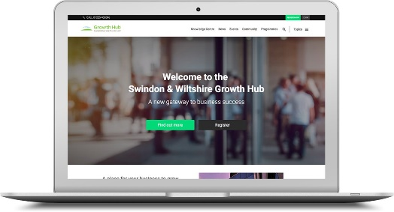

The business and work world has changed dramatically due to COVID-19 however A positive development to arise from the current situation is an increase in people looking at improve their skills for the workplace.
The good news is that many training providers have made their material available for free. We’ve pulled together this resource of some of the courses available for you and your business.
Lots of these online courses allow you to work through them at your own pace and some are accredited, providing you with evidence to support continued development.
We are always looking to expand this list so if you know of other free training available in the Swindon & Wiltshire area please get in touch with us with the details.
So, if you are looking to improve your digital skills, expand your knowledge for your sector or for your next career move, now is a great time to see what’s available.

Providers currently offering free training:
Open Learn from the Open University
Courses that have been proven to increase confidence and develop the skills needed to enter Higher Education and succeed with learning.
You can choose an OpenLearn course from a wide range of subjects. Some are based on Open University course materials. Others are written specifically for OpenLearn.
https://www.open.edu/openlearn/free-courses/full-catalogue

Wiltshire Collage & University Centre
A wide range of courses that vary from professional development within your organisation or for your own business to well-being and childcare focused courses.
https://www.wiltshire.ac.uk/distancelearning

New Collage Swindon
Access a range of level 2 NVQ’s, a great offering to up skill staff in SME’s and other organisations. Note some acceptance criteria is applicable.
https://www.newcollege.ac.uk/learn-with-us/free-qualifications

Swindon Borough Council
An adult community learning service provides more than 100 free courses, enrolling over 750 eligible learners, in 40 locations a year.
The service offers opportunities for residents to gain new skills in subjects like health and wellbeing, maths, english and IT, or to help them prepare to return to work.
https://www.swindon.gov.uk/info/20032/schools_and_education/402/adult_community_learning

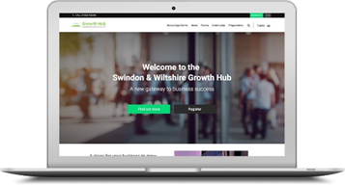

Future Learn
Choose from hundreds of online courses from top universities and specialist organisations.
https://www.futurelearn.com/courses

Oxford Home Study
Free home study courses online with certificates and no entry requirements. The range of courses offered is updated regularly
https://www.oxfordhomestudy.com/free-online-courses-with-certificates

Vision to Learn

UK Government funded, each course is nationally accredited and delivered in partnership with a further education college in England. Some eligibility criteria apply.

https://www.vision2learn.net/courses

Hubspot Academy

Free courses focusing on sales and digital marketing including social media, email and other forms of digital marketing
https://academy.hubspot.com/courses?page=1

Alison
Free online courses from the world’s leading experts. Join 15 million learners today.
https://alison.com/

Code Academy
Programming and computer science training helping you learn how to code.
https://www.codecademy.com/

Linkedin Learning
A range of business skills courses and training.
https://www.linkedin.com/learning/me

Forces Family

Support and training for families connected to the military

https://www.forcesfamiliesjobs.co.uk/business-start-ups/
https://www.forcesfamiliesjobs.co.uk/trainingcourses/

Finance and Management Business School
Skills based training covering Accountancy, Business Administration, Payroll, Information Technology, English and Maths.
https://www.fmbusinessschool.com/

Free Courses England
Offering accredited programmes, which are designed to complement employers’ existing in-house training provision and improve each learner’s knowledge and skills by assessing their core competencies against national standards.
https://freecoursesinengland.co.uk/free-courses-1

Google Digital Garage
A range of free learning content designed to help your business or in your career. You can learn by selecting individual modules or take an entire course end-to-end.
https://learndigital.withgoogle.com/digitalgarage/courses

IBM Training and Skills Blog
Includes foundational soft skills programs as well as technical training. You will need to create a sign in to view further content.

https://www.ibm.com/blogs/ibm-training/free-training-to-update-skills/

UK Government Careers and Skills Training
Search for courses and training online and get advice on qualifications.
https://www.gov.uk/career-skills-and-training

Cisco Networking Academy
A selection of courses covering Tech and digital subjects including Cybersecurity and programming.
https://www.cisco.com/c/m/en_sg/partners/cisco-networking-academy/index.html

Microsoft Learn
Training and courses to help you get the most out of Microsoft products such as Office 365 and much more.
https://docs.microsoft.com/en-gb/learn/

QA
Free training for furloughed or redundant staff. Places are limited to one course per person. Small businesses are encouraged to register their interest in using the scheme to support multiple members of staff on furlough.
https://www.qa.com/campaigns/free-training-scheme/

Udemy
A collection from the free courses in Udemy’s learning marketplace
https://www.udemy.com/courses/free/

Reed
Free training courses from a range of providers.
https://www.reed.co.uk/courses/free
BT Skills For Tomorrow
A varied range of courses covering life skills and business topics.
https://www.bt.com/skillsfortomorrow/index.html

Digital Business Academy
Skills that help you start, grow or join a digital business.
https://digitalbusinessacademy.technation.io/

Study UK
Are you thinking of studying in the UK and want to sample a UK university course, online and free of charge?
Or perhaps you have already enrolled, and are looking for advice on how to prepare to study and live in the UK?
Are you a UK graduate, taking the first steps to start your career?
If you answered 'yes' to any of these questions, Study UK has a free online course for you to try.
https://study-uk.britishcouncil.org/find/study-options/free-online-courses

Coursera
Build your skills with courses from top universities like Yale, Michigan, Stanford, and leading companies like Google and IBM.
https://www.coursera.org/courses?query=free

Barclays Back to Business Programme

The programme will help you assess the health of your business and identify how to sustain or grow it during a crisis, with scenarios you can use to see how the pandemic might affect your business in future. The key output will be a resilience plan for your business, which you can continue to test and evolve over time.

https://www.barclays.co.uk/business-banking/sectors/entrepreneurs/back-to-business-programme/

